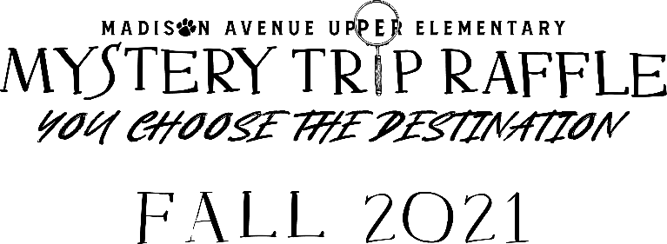
Welcome to the Madison Avenue Upper Elementary Mystery Trip Raffle, where YOU choose the destination! We are thrilled to once again support our school by raising funds to upgrade our playground and green space with new, more accessible equipment for our diverse student body. We are selling raffle tickets for a chance to win a $5,000 mystery travel voucher which will be fulfilled through Magnolia Travel Group with complimentary travel planning courtesy of Trey Tracy. Drawing will be held Friday, September 24, 2021.
- Enclosed is a booklet for 20 raffle tickets. Each ticket cost $10.

- Tickets may be purchased online at www.maueraffle.com. Online ticket sales options are strictly for online use only. Your personalized code to share with friends and family is located on the ticket. Online sales will be credited to your students ticket count and will be printed by the raffle team for the drawing. Follow us on Facebook for updates and links to share with friends and family.

- Raffle sale dates are August 27th – September 10th (2 weeks only)

- Please be sure each ticket stub is filled out completely.

- Tickets purchased online will have a stub filled out by the raffle team and entered in the hopper for the drawing.

- Need another booklet? Simply turn in the request slip included in this packet or email maueraffle@gmail.com

- Collection dates are Friday, September 3rd and Friday, September 10th ONLY. Top Seller awards will be given determined based on the collections.

- All ticket stubs, all associated money, and all unsold tickets must be returned Friday, September 10th for your child to be eligible for the incentives. Please send one check in for the total amount of money you received with your child’s name and homeroom in the memo line.

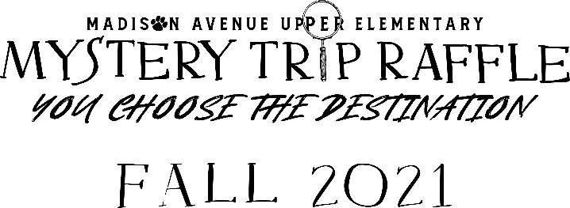

Our school has a goal of raising $40,000 to help fund the design and installation of phase 2 of our reimagined green space and playground accessible for all MAUE students. We know to upgrade our outside space will take more than one fundraising cycle but we believe time outside playing and learning is time well spent! We will offer online sales and a physical ticket books for each student. These books contain 20 tickets and a personal code for each student. This code can be shared with friends, family, and on social media. Using our online platform, RaffleBreeze, this code will allow your online sales to be assigned to your child making tracking of sales instant and updates easily provided to you and the school. Tickets purchased online are separate sales from the ticket book given to each student. Tickets purchased online are final sales and the purchaser will receive an email confirmation. The raffle team will put each of these tickets in the hopper for the drawing.
Covid has changed many things for us but we will not let it damped our school spirit! To help encourage our students and to be able to celebrate achieving our goal collectively while keeping with our Covid protocols, we have implemented new incentives we think our students will enjoy! If you joined the PTO at the Jaguar level, one MAE student in your family is already qualified to receive the first incentive.
Prizes:
$5,000 Mystery Trip Destination: Where YOU choose the location

Individual Incentives:
Sell 10 Tickets: Mystery Treat Bag
Sell 20: Mystery Snow Cone
Sell 30: $10 in Jag Store Credit

School Goal Incentives:
Reach $25,000: Stinky Feet Day! No shoes in class
Reach $30,000: 1 Hour of Electronics
Reach $40,000: Mystery Party

Top Class in the School: Mystery Party (Pizza)
Sell the Winning Ticket: Baskin Robbins Gift Card
Overall Top Seller: Amazon Gift Card
Winning Teacher: Mystery Gift

